1. In general, how does doubling the sample size change the confidence interval size?
2. Doubles the interval size
3. Halves the interval size
4. Multiplies the interval size by $\sqrt{2}$
5. Divides the interval size by $\sqrt{2}$
6. This question cannot be answered without knowing the sample size.
7. One month, the actual unemployment rate in Spain was 13.4%. If during that month you took a simple random sample of 100 Spaniards of working age and constructed a confidence interval estimate of the unemployment rate, which of the following would be true?
8. The center of the interval is 13.4
9. The interval contains 13.4
10. A 99% confidence interval estimate contains 13.4
11. The z-score of 13.4 is between $±2.576$
12. None of the above are true statements
13. The margin of error in a confidence interval estimate using z-scores covers which of the following?
14. Sampling error
15. Errors due to undercoverage and nonresponse in obtaining sample surveys
16. Errors due to using sample standard deviations as estimates for population standard deviations
17. Type I errors
18. Type II errors
19. In a survey funded by a biomedical research foundation, 750 of 1000 adult Americans said they didn’t believe they could come down with a sexually transmitted disease (STD). Construct a 95% confidence interval estimate of the proportion of all adult Americans who don’t believe they can contract an STD.

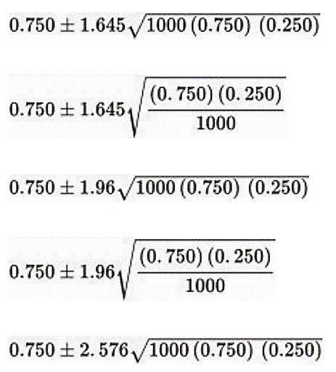

1. A politician wants to know what percentage of all voters support her position on the issue of forced busing for the racial integration of public schools. What size voter sample should be obtained to determine with 90% confidence the support level to within 4%?
2. 21 B. 25
3. 423 D. 600 E. 1691
4. A hypothesis test comparing two population proportions results in a P-value of 0.032. Which of the following is a proper conclusion?

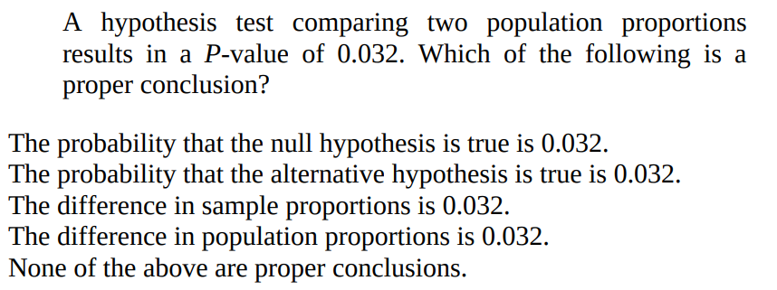

1. You plan to perform a hypothesis test with a level of significance of α = 0.05. What is the effect on the probability of committing a Type I error if the sample size is increased with everything else unchanged?

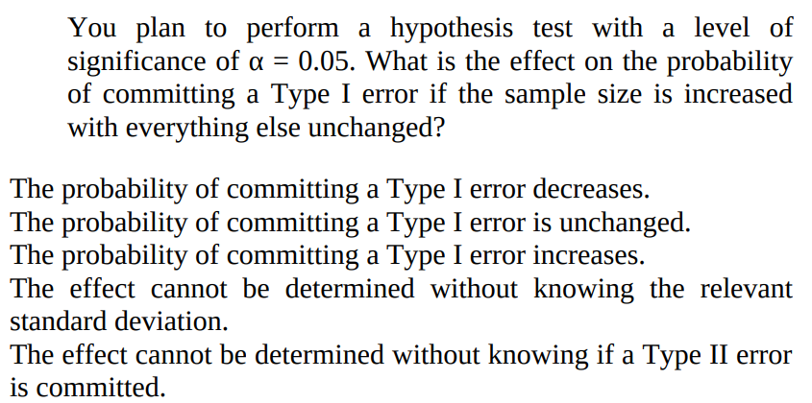

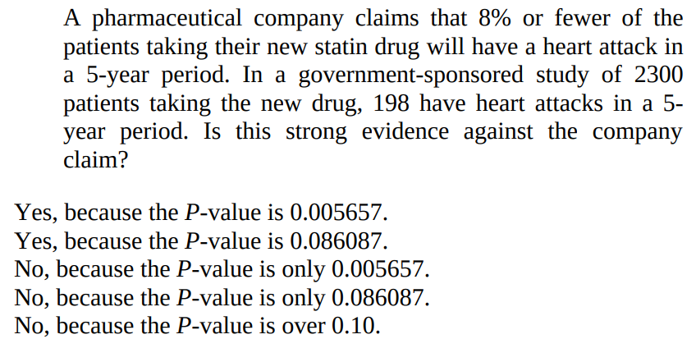

1. 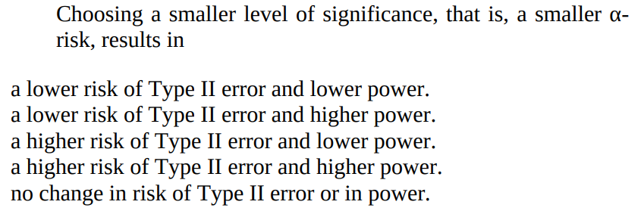
2. No vaccinations are 100% risk free, and the theoretical risk of rare complications always have to be balanced against the severity of the disease. Suppose the CDC (Center for Disease Control) decides that a risk of one in a million is the maximum acceptable risk of GBS (Guillain-Barré syndrome) complications for a new vaccine for a particularly serious strain of influenza. A large sample study of the new vaccine is conducted with the following hypotheses:

H0 : The proportion of GBS complications is 0.000001 (one in a million).

Ha : The proportion of GBS complications is greater than 0.000001.

The P-value of the test is 0.138.

1. Interpret the P-value in the context of this study.
2. What conclusion should be drawn at the α = 0.10 significance level?
3. Given this conclusion, what possible error, Type I or Type II, might be committed? Give a possible consequence of committing this error.
4. A 20-year study of 5000 British adults noted four bad habits: smoking, drinking, inactivity, and poor diet. The study looked to show that there is a higher death rate (proportion who die in a 20-year period) among people with all four bad habits than among people with none of the four bad habits.
5. Was this an experiment or observational study? Explain.
6. What are the null and alternative hypotheses?
7. What would be the result of a Type I error?
8. What would be the result of a Type II error?
9. Of the 314 people who had all four bad habits, 91 died during the study, while of the 387 people with none of the four bad habits, 32 died during the study. Calculate and interpret the P-value in the context of this study.